**UNIVERSITY ADMIT ELIGIBILTY PREDICTOR**

**PROJECT REPORT**

***Submitted By***

**A. NASHIAH JUSTIN**

**R. RUHI MISBAAH**

**J. ANUSHIYA**

**I. JOSHINA**

**TEAM ID: PNT2022TMID34570**

***in partial fulfillment for the award of the degree***

***of***

**BACHELOR OF TECHNOLOGY**

***in***

**INFORMATION TECHNOLOGY**

**PONJESLY COLLEGE OF ENGINEERING, NAGERCOIL**

**ANNA UNIVERSITY::CHENNAI 600025**

**NOVEMBER 2022**

**TABLE OF CONTENT**

**CHAPTER TITLE PAGE**

**NO NO**

**ABSTRACT 5**

1. **INTRODUCTION 6** 
   1. Purpose of document 6
   2. Project summary 6
   3. Motivation 7
   4. Significant 7
   5. Project scope 7
   6. System purpose 8

1.6.1Users

1.6.2 Locations

1.6.3Responsibilities

* 1. Limitations and future works 9
  2. Beneficiaries 9
  3. Overview of document 9

1. **FUNCTIONAL OBJECTIVES 11**  
   1. High Priority 11
   2. Medium Priority 11
   3. Low Priority 11
   4. Literature Survey 12
2. **ARCHITECTURE 13**

**4 NON-FUNCTIONAL**

**REQUIREMENTS 14**

* 1. Reliability 14
  2. Usability 14
  3. Performance 14
  4. Security 14
  5. Online user documentation and

help 15

**4.6** Supportability 15

1. **USE CASE MODEL 16**
   1. Use Case Diagram 16
   2. Use Case Descriptions 17

**5.3** Flowchart 26

1. **SOFTWARE AND HARDWARE PLATFORMS 27**
   1. Hardware 27
   2. Software 27
2. **IMPLEMENTATION 28**
3. **SCREENSHOTS 34**
4. **CONCLUSION AND FUTURE ENHANCEMENT 38**
   1. Conclusion 38

**9.2** Future Enhancement 38

**ABSTRACT**

This project University Admit Eligibility Predictor is created with the idea of making the complicated and tiring process of college admissions easier for students looking to apply for universities by checking what are the possibilities of them getting into their dream universities based on various factors. The students are required to fill in their personal details such as university marks, CGPA, and also additional exam scores such as GRE, IELTS, TOEFL, etc. The administrator of universities can view these details of the students enrolled. Using this software, the entrance seat allotment becomes a lot easier and can be implemented way faster than the normal procedure.

Based on the obtained data set, various models are trained and universities carrying similar properties are suggested so that it increases the chances of students getting into the universities they applied for. Classification algorithms also predict the rate of acceptance for any student to a university. This project also makes use of Machine-Learning model which predicts the eligibility of students for admission in the desired Universities.

The main advantage of this project is the computerization of the seat allotment process. The administrator has the power of allotment. They can add the allotted seats into a file and the details are saved into the system. The total time consumption for the allotment process is vastly reduced which saves time for all.

**CHAPTER-1**

**INTRODUCTION**

* 1. **Purpose of Document**

This is a Requirements Specification Document for our web-based project “UNIVERSITY ADMIT ELIGIBILITY PREDICTOR”. It is an Technology based application that asks for the users to input their academic transcripts data and calculates their chances of admission into the University Tier that they selected. It also provides an analysis of the data and shows how chances of admissions can depend on various factors. This document describes the scope, objectives and goals of the system. In addition to describing the non-functional requirements, this document models the functional requirements with use cases, interaction diagrams and class models. This document is intended to direct the design and implementation of the target system in an object-oriented language.

* 1. **Project Summary**

Project Name: UNIVERSITY ADMIT ELIGIBILITY PREDICTOR

Project type: Web Application

Developers: Nashiah Justin A

Ruhi Misbaah R

Anushiya J

Joshina I

Languages used: Python, HTML, Java script, CSS

Domain: Technology

Development Platform: Anaconda

Data Set Used: Admissions predictor dataset

* 1. **Motivation**

In the current world scenario, it is not enough for a student to just have an Under Graduate degree. Most employers now look for higher qualifications in their new recruits. As a result, the demands for a good higher education are at an all time high. A lot of students from India prefer to continue their higher education with foreign universities, especially in the United States, Canada, Germany.

In order to get admitted to these foreign universities, a set of academic requirements are needed. However, because of the sheer number of universities of different levels, students are often stuck in a dilemma till the very last minute as to whether or not their applications will be accepted or not as no concrete documentation is available which lists the requirements.

**1.4 Significance**

This project was developed to provide a solution to that problem. Not only do we provide a single platform that documents all the requirements as well as the different tiers of universities, but our website also incorporates an AI Model that was built after considering many leading Machine Learning Algorithms, to provide the most accurate prediction of how much of a chance of admissions does a student’s current grades and other academic transcripts allow them in the tier of universities of their choice.

* 1. **Project Scope**

The scope of this project is a web application that allows users to enter their academic data and get predictions of their chances of admissions in the university tier of their choosing. It also provides them answers to the most common FAQ’s that arise when thinking of admissions abroad for Post Graduate studies.

It also provides an analysis based on the data set used that shows how the different parameters affect chances of admissions. A Database will also be implemented for the system so that students can save their data and review and edit it as they progress with the most recent predictions being saved with their profile.

**1.6 System Purpose**

* + 1. **Users**

Students- The people who will benefit the most from using this system are Indian students. Especially students looking to pursue their higher education from foreign universities, particularly in the United States.

Administrators- The administrator shall be able to access all the data stored in the application.

**1.6.2 Locations**

The system will be available to all users from any location as long as they have an Internet connection. The administrator can also access the website from any location as long as he has the correct login credentials and access to the Internet.

**1.6.3 Responsibilities**

The primary responsibilities of the system are:

* Provide customers access to the prediction model
* Provide answers to most common FAQs regarding PG Admissions abroad
* Provide administrator access to all records
* Provide analysis of how the various academic factors affect university admission

Other desired features of the system:

* Maintaining a profile for each user
* Password protection for each account
  1. **Limitations and Future Work**
* Requires active internet connection.
* System will provide inaccurate result if data entered incorrectly.
* Future work in the project could include weighing in the features that have been ignored as of yet like percentage seats for Foreign Students. Other criterions like Co-circular achievements, Leadership positions held, job experience etc can also be included as metrics for the model.
  1. **Beneficiaries**
* It helps student for making decision for choosing a right college.
* Here the chance of occurrence of error is less when compared with the existing system.
* It is fast efficient and reliable.
* Avoids data redundancy and inconsistency.
* Very user-friendly.
* Easy accessibility of data.
  1. **Overview of Document**

**Section 1: Functional Objectives**

Each objective gives a desired behaviour for the system and a measure to determine if the final system has successfully met the objective. These objectives are organized by priority. In order for the new system to be considered successful, all high priority objectives must be met

**Section 2: Non-Functional Objectives**

This section is organized by category. Each objective specifies a technical requirement or constraint on the overall characteristics of the system. Each objective is measurable.

**Section 3: Use Case Model**

The specific behavioural requirements of the system are detailed in a series of use cases. Each use case accomplishes a business task and shows the interaction between the system and some outside actor. The system use case diagram depicts the interaction between all uses cases and system actors. A sequence diagram is also provided to show the flow of the application.

**Section 4: Software and Hardware used**

This section details the Hardware, Software and Online tools used for developing the UNIVERSITY ADMIT ELIGIBILITY PREDICTOR project.

**Section 5: Code Snippets**

This section provides some of the major code snippets used to develop the project.

**Section 6: Screenshots**

This section provides Screenshots of the UNIVRSITY ADMIT ELIGIBILITY PREDICTOR Application.

**Section 7: Testing Report**

This section details different test cases needed for the project and how they were implemented.

**Section 8: Validation**

This Section contains a final validation of the system where the system is checked to see if all the promised functional and non-functional requirements as mentioned in the SRS have been fulfilled or not.

**CHAPTER-2**

**FUNCTIONAL OBJECTIVES**

* 1. **High Priority**
* The system shall provide the user access to the AI predictor, wherein the user will be able to fill in a form with their academic transcripts data (GRE Score, TOFL Score, CGPA, SOP Score, LOR Score, Research experience), choose the tier of university they wish to apply to (1-5(top level)) and then get a prediction of their chances of admissions to that level university based on the mapping between their requirements and the student’s results.
* The system shall provide the administrator access to all the records in the database on a “read-only” basis.
  1. **Medium Priority**
* The system shall provide all the users with answers to the most common FAQ’s like- “Distribution of University Tiers”, “University Admissions Criteria”
* The system shall allow the user’s details to be stored for the next time they return to the website. If the user chooses to take a new evaluation, the most recent inputs as well as prediction shall replace any previous data.

* 1. **Low Priority**
* The system shall provide users an analysis of how the various factors mentioned in the form affect their chances of admissions as well as what is the general trend of applications to the various tiers of universities.
  1. **Literature Survey**

1. **Existing Problem:**

Previous research done in this area used Naive Bayes algorithm which will evaluate the success probability of student application into a respective university but the main drawback is they didn’t consider all the factors which will contribute in the student admission process like TOEFL/IELTS, SOP, LOR and under graduate score. Bayesian Networks Algorithm have been used to create a decision support network for evaluating the application submitted by foreign students of the university. This model was developed to forecast the progress of prospective students by comparing the score of students currently studying at university. The model thus predicted whether the aspiring student should be admitted to university on the basis of various scores of students. Since the comparisons are made only with students who got admission into the universities but not with students who got their admission rejected so this method will not be that much accurate.

1. **Proposed Problem:**

These problems can be resolved by using regression algorithms/classification algorithms as they can consider most of the features for prediction. Linear regression/KNN classification/Random can be used as the machine learning model for the model XG boost model can also be used which performs better on small to medium scale datasets but the model giving accurate and desired results only will be selected.

The aim of the proposed system is to address the limitations of the current system. The requirements for the system have been gathered from the defects recorded in the past and also based on the feedback from users of previous metrics tools. Following are the objectives of the proposed system.

* Reach to geographically scattered student.

* Reducing time in activities.

* Paperless admission with reduced man power.

* Operational efficiency.

**CHAPTER-3**

**ARCHITECTURE**



**CHAPTER-4**

**NON-FUNCTIONAL REQUIREMENTS**

**4.1 Reliability**

* The system shall be completely operational all hours of the day unless system failure or up gradation work is to be performed.
* Down time after a failure shall not exceed 24 hours.

**4.2 Usability**

* No training is required to use the website.
* The form home, about, FAQ and analysis pages load up within 10 seconds.
* The results from the predictor should not take more than 30 seconds.

**4.3 Performance**

* The system can support any number of users at a time.
* The mean time to view a web page over a 56Kbps modern connection shall not exceed 5 seconds.

**4.4 Security**

* The system shall provide password protected access to the website to all users –students and administrations both.

**4.5 Online user documentation and help**

* The system shall provide a web page that explains how to navigate the site. This page should be customized based on what pages that user is allowed to access.
* This help page should be accessible from all other pages.
  1. **Supportability**
* The system will be able to incorporate more features without major reengineering. The system web site shall be viewable from Internet Explorer 4.0 or later, Netscape Navigator/Communicator 3.0 later and the America Online web browser version 3.0 or later.

**CHAPTER - V**

**USE CASE MODEL**

**5.1 Use Case Diagram**

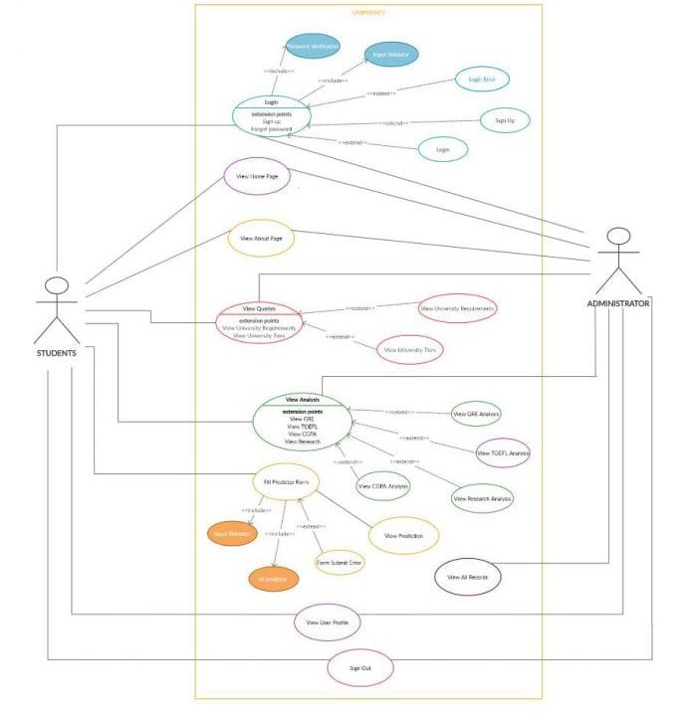

**5.2 Use Case Descriptions**

* **Login User**

|  |  |
| --- | --- |
| **Use Case Name:** | **Login User** |
| Summary | In order to access the system and the prediction model, a user must sign in. It also determines whether a user is an Administrator, in which case, it offers different functionalities. |
| Basic Flow: | 1. The use case starts when user indicate that he wants to login. 2. The system requests the username and password. 3. The user enters his username and password. 4. The system verifies the username and password against all registered users. 5. The system starts a login session and displays the home page. |
| Alternate Flows: | Step 1: If username is invalid, or field is left blank the use case goes back to step 2.  Step 2: If the password is invalid or field is left blank the system requests that the user re-enter the password. When the user enters another password the use case continues with step 4 using the original username and new password. |
| Extensions points: | 1. Sign Up- for new users 2. Forgot Password |
| Precondition: | User is registered. |
| Post Columns: | The user can now obtain data and perform functions according to his registered access level. |

* **View Home Page**

|  |  |
| --- | --- |
| **Use Case Name:** | **View Home Page** |
| Summary | The user can now view the home page of the app and get access to the other tabs. |
| Basic Flow: | 1. The user case starts when the user gets logged in to the system. 2. The Home page is now visible to the user which holds all the information about how to work with the different elements of the application. |
| Alternate Flows: | None |
| Extensions Points: | Has tabs to access all other pages but no extension points as such. |
| Preconditions: | User must be logged in to the system. |
| Postconditions: | Other functionalities available to the user depend upon his/her clearance level. |
| Business Rules: | None |

* **View About Page**

|  |  |
| --- | --- |
| **Use Case Name:** | **View About Page** |
| Summary | The user can now view the about page of the app and get access to the other tabs. |
| Basic Flow: | 1. The use case starts when the user clicks on the about tab on top of the Home page. 2. The About page is now visible to the user which holds all the information about how, why and by whom the application was developed. |
| Alternate Flows: | None |
| Extension Points: | Has tabs to access all other pages but no extension points as such. |
| Preconditions: | User must be logged in to the system. |
| Postconditions: | None |
| Business Rules: | None |

* **View Queries**

|  |  |
| --- | --- |
| Use Case Name: | View Queries |
| Summary | The user can now view the queries the app provides answers to and get access to the other tabs. |
| Basic Flow: | 1. The use case starts when the user clicks on the “Queries” tab. 2. The drop-down menu appears for the user to choose which query he/she wants the answer to. |
| Alternate Flows: | None |
| Extension Points: | Has tabs to access all other pages.  Extensions Points are:   * + - 1. Universities Tiers page- A page that answers queries regarding how the university tiers are divided.       2. University Requirements page- It provides a table of the required mean Scores in order to get admitted to each tier of universities. |
| Preconditions: | User must be logged in to the system. |
| Postconditions: | None |
| Business Rules: | None |

* **View Analysis**

|  |  |
| --- | --- |
| **Use Case Name:** | **View Analysis** |
| Summary | The user can now view the analysis the app provides of how the various academic scores affect their chances of admissions. |
| Basic Flow: | 1. The use case starts when the user clucks on the “Analysis” tab. 2. The drop-down menu appears for the user to choose which analysis he/she wants to view. |
| Extensions Points: | Extension point are:   1. GRE Score Analysis. 2. TOEFL Score Analysis. 3. CGPA Analysis. 4. Research Experience Analysis. |
| Alternate Flows: | None |
| Preconditions: | User must be logged in to the system. |
| Postconditions: | None |
| Business Rules: | None |

* **Full Predictor Form**

|  |  |
| --- | --- |
| **Use Case Name:** | **Full Predictor Form** |
| Summary | The Students can now access the admissions by filling up the form and getting their predicted chances of admissions. |
| Basic Flow: | 1. The use case starts when the user clicks on the “predictor” tab 2. The user can access the form and fill up all the data required by the system. All data fields must be filled. 3. On clicking the submit button, the data is sent to the predictor and the results are generated. 4. The resultant prediction of chances of admissions are returned to the user. |
| Alternate Flows: | Step 3: If all the fields are not filled before clicking on enter, the user is prompted to fill out the remaining fields and process goes back to step 2 and continues from there. |
| Extension Points: | Has tabs to access all other pages No extension points as such. |
| Preconditions: | User must be logged to the system as a student. |
| Postconditions: | None |
| Business Rules: | This functionality is only available to a user who is registered as a student. |

* **View All Records**

|  |  |
| --- | --- |
| **Use Case Name:** | **View All Users** |
| Summary | The administrator can access all the records for all users that are registered in the system. |
| Basic Flows: | 1. The use case starts when the users is verified to be an administrator. 2. Once the admin clicks on the view all tab, all the records currently stored in the system become available to him/her. |
| Alternate Flows: | None |
| Extension Points: | Has tabs to access all other pages.  No Extensions Points as such. |
| Preconditions: | User must be logged in to the system and verified as an admin. |
| Postconditions: | None |
| Business Rules: | This functionality is only available to users who are verified Administrators of the system. |

* **View User Profile**

|  |  |
| --- | --- |
| **Use Case Name** | **View User Profile** |
| Summary | The user can view his/her own profile. Students can also see the most recent values of their scores and prediction as stored in the system. |
| Basic Flow: | 1. The use case starts when the user clicks on the “Queries” tab. 2. The drop-down menu appears for the user to choose which query he/she wants the answer to. |
| Alternate Flows: | None |
| Extensions Points: | Has tabs to access all other pages.  No Extension points as such. |
| Preconditions: | User must be logged in the system. |
| Postcondition: | None |
| Business Rules: | None |

* **Sign Out**

|  |  |
| --- | --- |
| **Use Case Name:** | **Sign Out** |
| Summary | The user can sign out of the system and be redirected to the login age. |
| Basic Flow: | 1. The use case starts when the user clicks on the “Logout” tab. 2. The user session is ended, and he/she gets redirected to the login page. |
| Alternate Flows: | None |
| Extensions Points: | None |
| Precondition: | User must be logged in to the system. |
| Postconditions: | None |
| Business Rules: | Some data and functions are restricted to certain types of users or users with a particular access level. |

**5.3 FLOWCHART**

User enters web applications

**CHAPTER - 6**

START

DISPLAY OUTPUT

PREDICTION

SUBMIT

ENTER DETAILS

**SOFTWARE AND HARDWARE PLATFORM**

**6.1 Hardware**

A home PC -capable of handling light ML processing.

Device Specifications:

1. I5 10th Gen processor
2. 8 GB RAM
3. 64bit Operation System
   1. **Software**

* **Anaconda (Jupiter Notebook)**

Project Jupiter is a non-profit organization created to “develop open-source software, open-standards, and services for interactive computing across dozens of programming languages”. [2] Spun off from I Python in 2014 by Fernando Perez, Project Jupiter supports execution environments in several dozen languages. Project Jupiter’s name is a reference to the three core programming languages supported by Jupiter, which are Julia, Python and R, and also a homage to Galileo’s notebooks recording the discovery of the moons of Jupiter.

**CHAPTER-7**

**PROJECT DELIVERABLES**

**7.1 IDEATION PHASE**

7.1.1 BRAINSTORMING

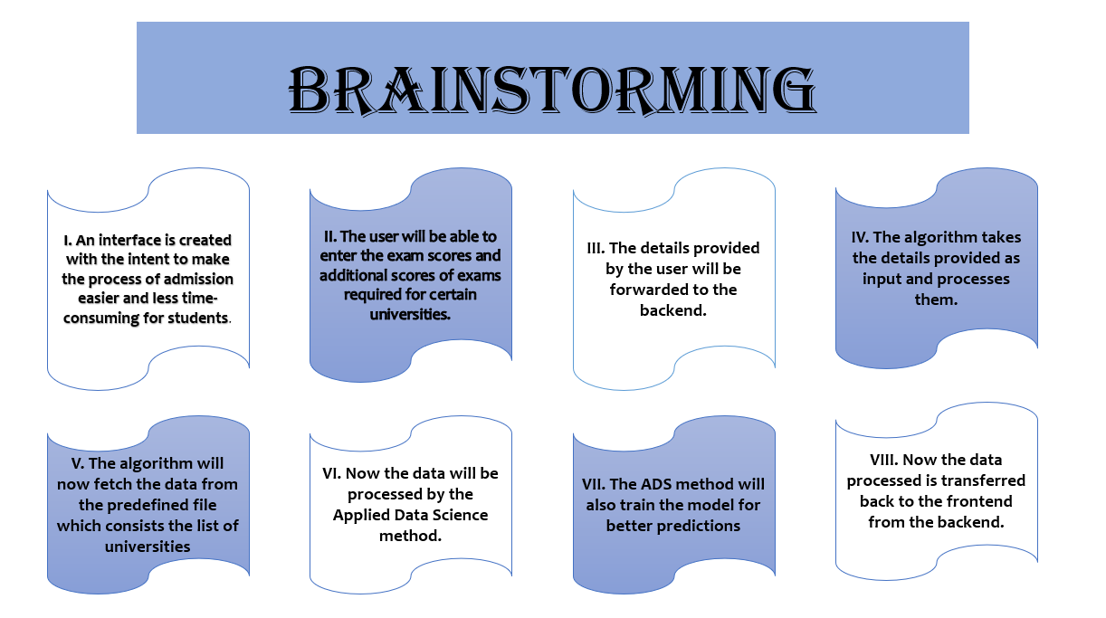

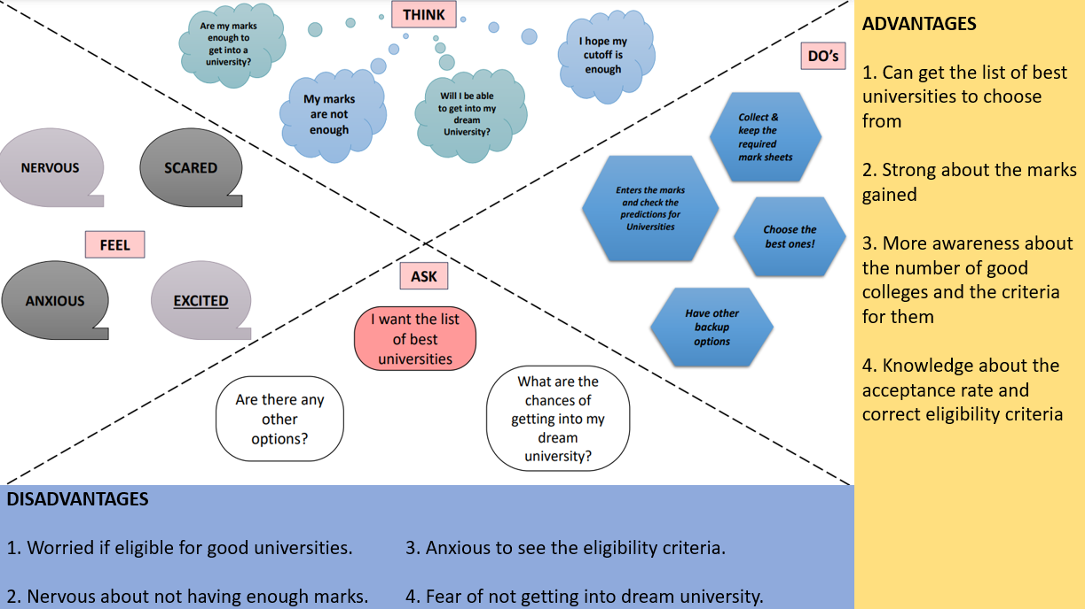7.1.2 EMPATHY MAP

7.2.3 LITERATURE SURVEY

**EXISTING PROBLEM:**

Previously, much research has been done in this field and they use Naïve-Bayes algorithm. Here, Naïve-Bayes algorithm is used for calculating the possibility of successfully getting into the university the user wishes. But here the major drawback of this is that they didn’t consider the various other factors which will increase the chances of getting admission to a university like GRE scores, IELTS/TOEFL scores, etc. Bayesian Networks Algorithms are used to create a network for evaluating the eligibility criteria based on data submitted by foreign students. Thus, it helps aspiring students to have a better vision of eligibility criteria for specific colleges by comparing the data already submitted by various students who successfully got into the university. But this model only shows the comparisons of data from students who successfully got admission but not data from the students who got rejected. Hence, this method will is not very accurate and will not gove a clear vision to students.

**PROPOSED SOLUTION:**

These various drawbacks can be solved by using classification and regression algorithms as they have emerged as the best for prediction features. Linear Regression/ KNN Classification / Random Forest Regressor can be used as the Machine Learning model for this model. XG Boost model also can be used as it performs best for small to medium-sized datasets. This will address the problems and limitations of the existing model which is the aim of this proposed solution.

The defects from the past model have been gathered as the requirements for this system based on the user feedback.

Following are the objectives of Proposed System: ¬

* Less time-consuming.
* Efficiency in operating and administering.
* Eco- Friendly and paperless admission.
* Usage of less manpower.
* Access to students all around the world.

7.2.4 PROBLEM STATEMENT

* The problem statement for this project is to design a userfriendly college or university predictor and to provide probabilistic insight into the whole admission process, the cut-offs required for respective colleges, and eligibility criteria according to the preferences of the students.
* It has always been a troublesome and tiring process for students to search for a good university/college that provides their preferred course or to choose a course from the options available options considering the futuristic career options.
* At times when the students are not sure about what field to get into, it is very hard and difficult for them to find universities based on their scores.
* The main idea of this project is to lessen their burden by providing a list of good colleges or universities with their marks scored and additional performances as input.

**AIM:**

* To help students in shortlisting comparing with their profile.
* The predicted output will give students a clear vision and guide them throughout their admission process
* This analysis also gives a clear idea about the eligibility criteria for the students who are or will be preparing.

**CHAPTER-7**

**IMPLEMENTATION**

import numpy as np

import pandas as pd

#import os

from matplotlib import pyplot as plt

from sklearn import preprocessing

from sklearn.preprocessing import StandardScaler

from sklearn.model_selection import train_test_split

from sklearn.linear_model import LinearRegression

from sklearn.tree import DecisionTreeRegressor

from sklearn.ensemble import RandomForestRegressor

import seaborn as sns

sns.set(style='white')

sns.set(style='whitegrid', color_codes=True)

df = pd.read_csv("Admission_Predict_Ver1.1.csv")

df.rename(columns = {'Chance of Admit ':'Chance of Admit', 'LOR ':'LOR'}, inplace=True)

df.drop(labels='Serial No.', axis=1, inplace=True)

fig, ax = plt.subplots(figsize=(10,10))

sns.heatmap(df.corr(), annot=True, cmap='Blues')

plt.figure(figsize=(20,6)) plt.subplot(1,2,1)

sns.distplot(df['CGPA'])

plt.title('CGPA Distribution of Applicants')

plt.subplot(1,2,2)

sns.regplot(df['CGPA'], df['Chance of Admit'])

plt.title('CGPA vs Chance of Admit')

plt.figure(figsize=(20,6))

plt.subplot(1,2,1)

sns.distplot(df['GRE Score'])

plt.title('Distributed GRE Scores of Applicants')

plt.subplot(1,2,2)

sns.regplot(df['GRE Score'], df['Chance of Admit'])

plt.title('GRE Scores vs Chance of Admit')

plt.figure(figsize=(20,6))

plt.subplot(1,2,1)

sns.distplot(df['TOEFL Score'])

plt.title('Distributed TOEFL Scores of Applicants')

plt.subplot(1,2,2)

sns.regplot(df['TOEFL Score'], df['Chance of Admit'])

plt.title('TOEFL Scores vs Chance of Admit')

fig, ax = plt.subplots(figsize=(8,6))

sns.countplot(df['Research'])

plt.title('Research Experience')

plt.ylabel('Number of Applicants')

ax.set_xticklabels(['No Research Experience', 'Has Research Experience'])

fig, ax = plt.subplots(figsize=(8,6))

sns.countplot(df['University Rating'])

plt.title('University Rating')

plt.ylabel('Number of Applicants')

targets = df['Chance of Admit']

features = df.drop(columns = {'Chance of Admit'})

X_train, X_test, y_train, y_test = train_test_split(features, targets, test_size=0.2, random_state=42)

linreg = LinearRegression()

linreg.fit(X_train, y_train)

y_predict = linreg.predict(X_test)

linreg_score = (linreg.score(X_test, y_test))*100

linreg_score

@app.route('/predictor', methods =['GET','POST'])

def predictor():

form = PredictorForm()

if form.is_submitted():

#form inputs

Record_dictionary2=request.form.to_dict()

del Record_dictionary2['csrf_token']

del Record_dictionary2['submit']

gre=float(request.form['gre'])

toefl=float(request.form['toefl'])

#rating=float(request.form['uni'])

sop=float(request.form['sop'])

lor=float(request.form['lor'])

cgpa=float(request.form['cgpa'])

research=float(request.form['research'])

uni=float(request.form['uni'])

#global personId

#Record_dictionary2["person_id"]=personId['_id']

Record_dictionary2["username"]=session['user']

#----------------------------------prediction model-----------------

import numpy as np

import pandas as pd

#from matplotlib import pyplot as plt

import sklearn

import sklearn.preprocessing

from sklearn.preprocessing import StandardScaler

from sklearn.model_selection import train_test_split

from sklearn.linear_model import LinearRegression

from sklearn.tree import DecisionTreeRegressor

#from sklearn.ensemble import RandomForestRegressor

#import seaborn as sns

import pickle

#sns.set(style='white')

#sns.set(style='whitegrid', color_codes=True)

df = pd.read_csv("static\Admission_Predict_Ver1.1.csv")

df.rename(columns = {'Chance of Admit ':'Chance of Admit', 'LOR ':'LOR'}, inplace=True)

df.drop(labels='Serial No.', axis=1, inplace=True)

targets = df['Chance of Admit']

features = df.drop(columns = {'Chance of Admit'})

X_train, X_test, y_train, y_test = train_test_split(features, targets, test_size=0.2, random_state=42)

test=[[gre,toefl,uni,lor,sop,cgpa,research]]

X_test=np.vstack((X_test,test))

rec_num=X_test.shape[0]

#scaler = StandardScaler()

#X_train = scaler.fit_transform(X_train)

#X_test = scaler.fit_transform(X_test)

linreg = LinearRegression()

linreg.fit(X_train, y_train)

pickle.dump(linreg, open('model.pkl','wb'))

model=pickle.load(open('model.pkl','rb'))

#print(model.predict([[gre,toefl,rating,sop,lor,cgpa,research]]))

#--------------------------------------end model ------------------------------------

y_predict=linreg.predict(X_test)

prediction=round(y_predict[rec_num-1]*100,2)

#prediction=round(y_predict[0]*100,2)

if(prediction>=75):

message="Good Job! Your current scores show that you are well on the path to joining your dream college! Keep up the hardwork and dont forget about the other factors of your application"

elif(prediction>=50 and prediction<75):

message="Needs Improvement! Your current scores show that some more effort to get you to your dream college! If improvement in these areas is not possible, focus on the other factors of your application"

else:

message="Sorry! Your current scores show that the chances of you getting into this tier of universities are very slim! Might we suggest that you look at other options?"

#linreg_score = (linreg.score(X_test,y_test))

#print(linreg_score)

Record_dictionary2['prediction']=prediction

client1 = pymongo.MongoClient('localhost',27017)

db = client1['admin']

db2 =client1["UNIPREDICT"]

collection=db2["students"]

collection2=db2["data_table"]

temp=collection.find({'username':Record_dictionary2['username']})

print (temp)

for i in temp:

Record_dictionary2["First_Name"]=i['firstname']

Record_dictionary2["Last_Name"]=i['lastname']

#Record_dictionary3=Record_dictionary2

collection2.find_one_and_update(

{'username': session['user']},

{"$set":

{'gre' : gre,

'toefl': toefl,

'uni': uni,

'cgpa': cgpa,

'research': research,

'sop' : sop,

'lor': lor,

'prediction': prediction}

},upsert=True)

return render_template('pages/output.html', prediction=prediction, message=message)

return render_template('forms/predictor.html', form

**CHAPTER-8**

**SCREENSHOTS**

* **Index:**

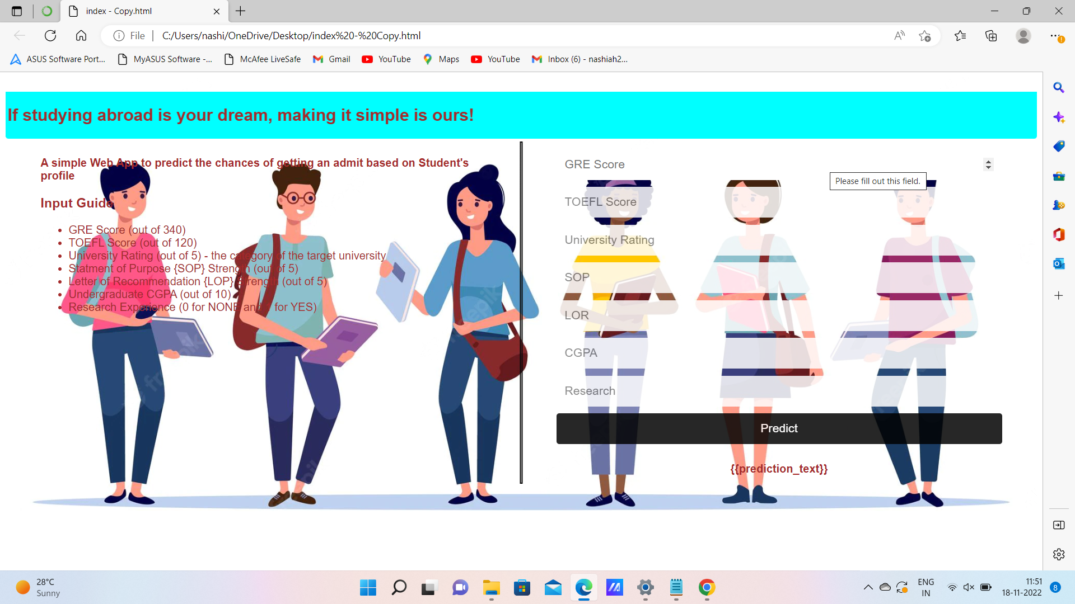

* **Chance:**

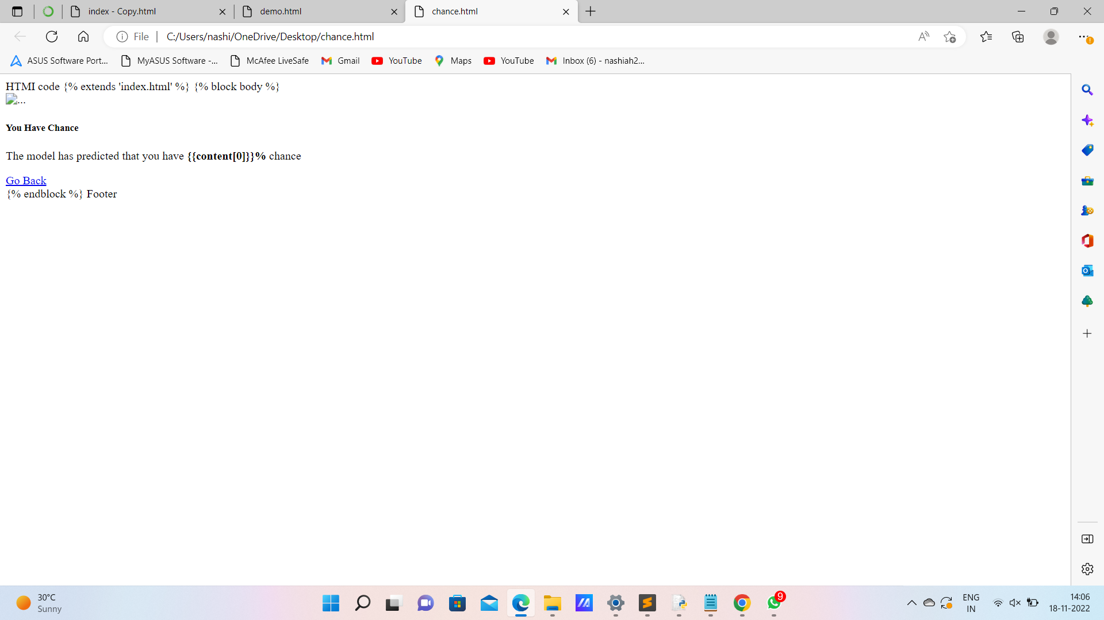

* **No Chance:**

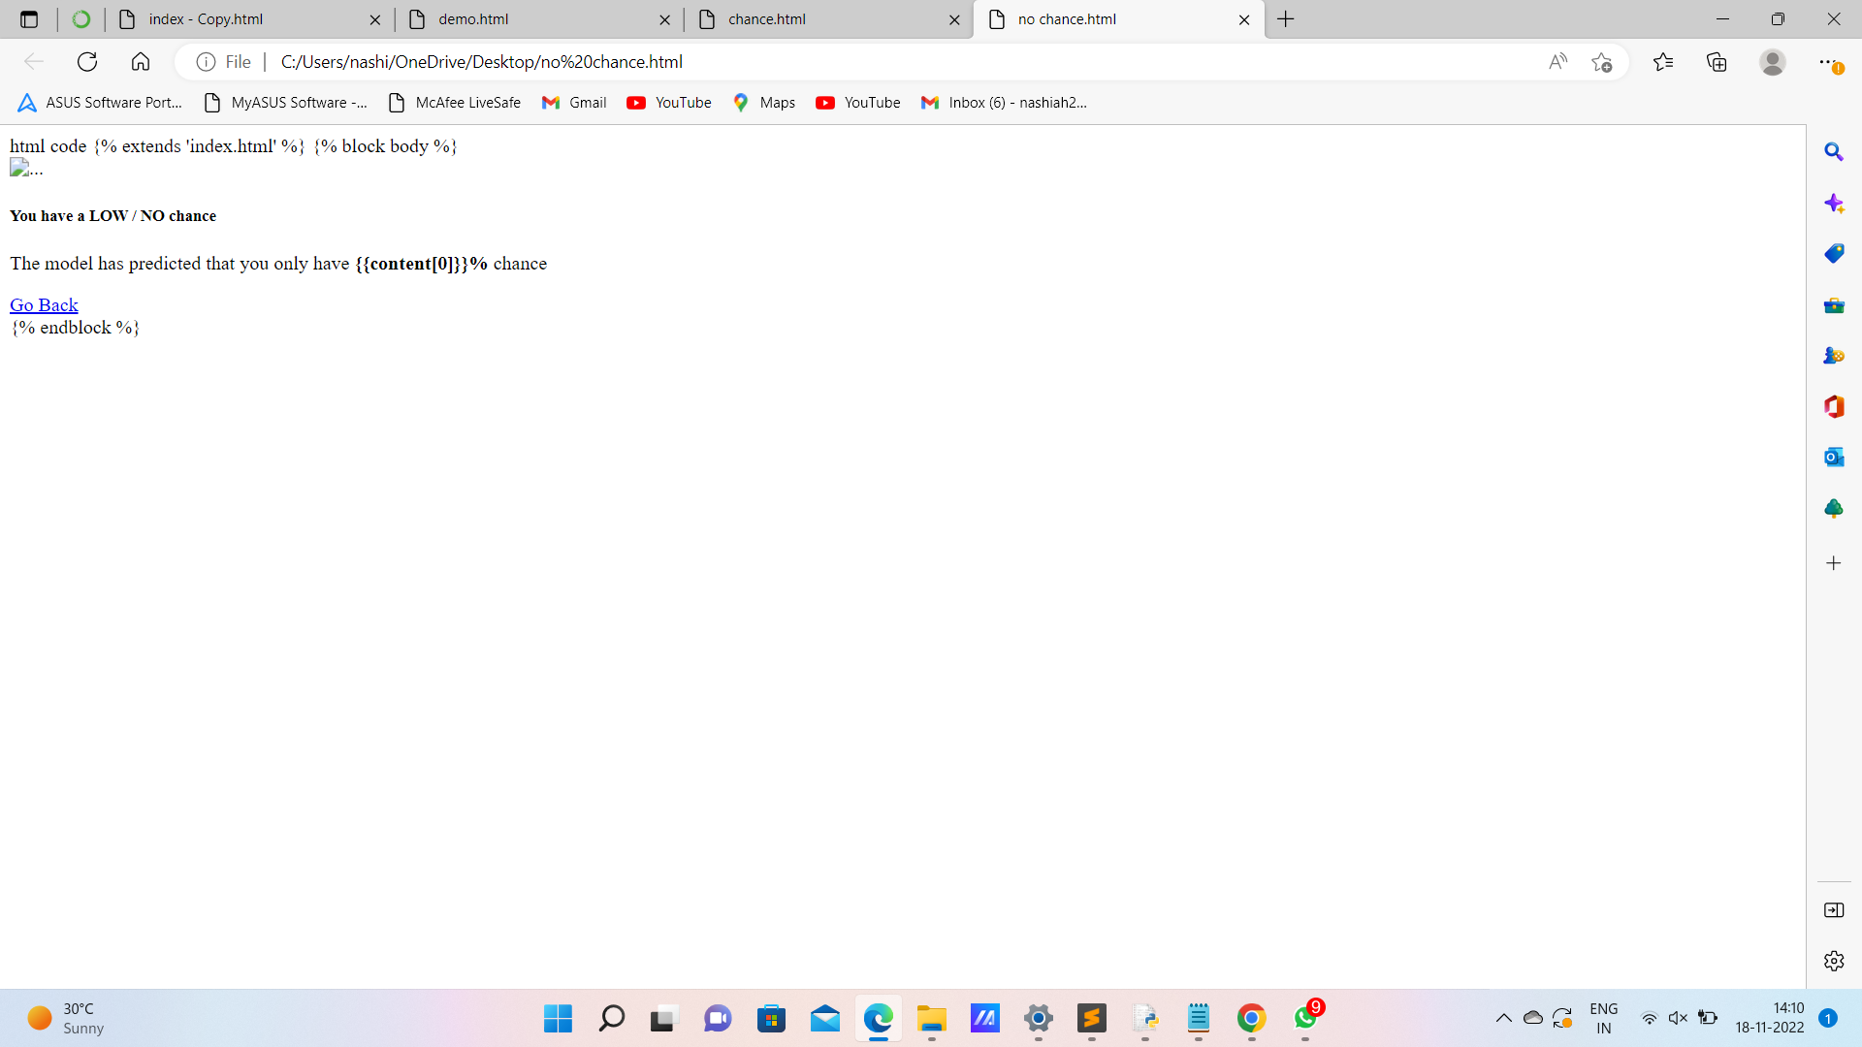

* **Enter Your Details:**

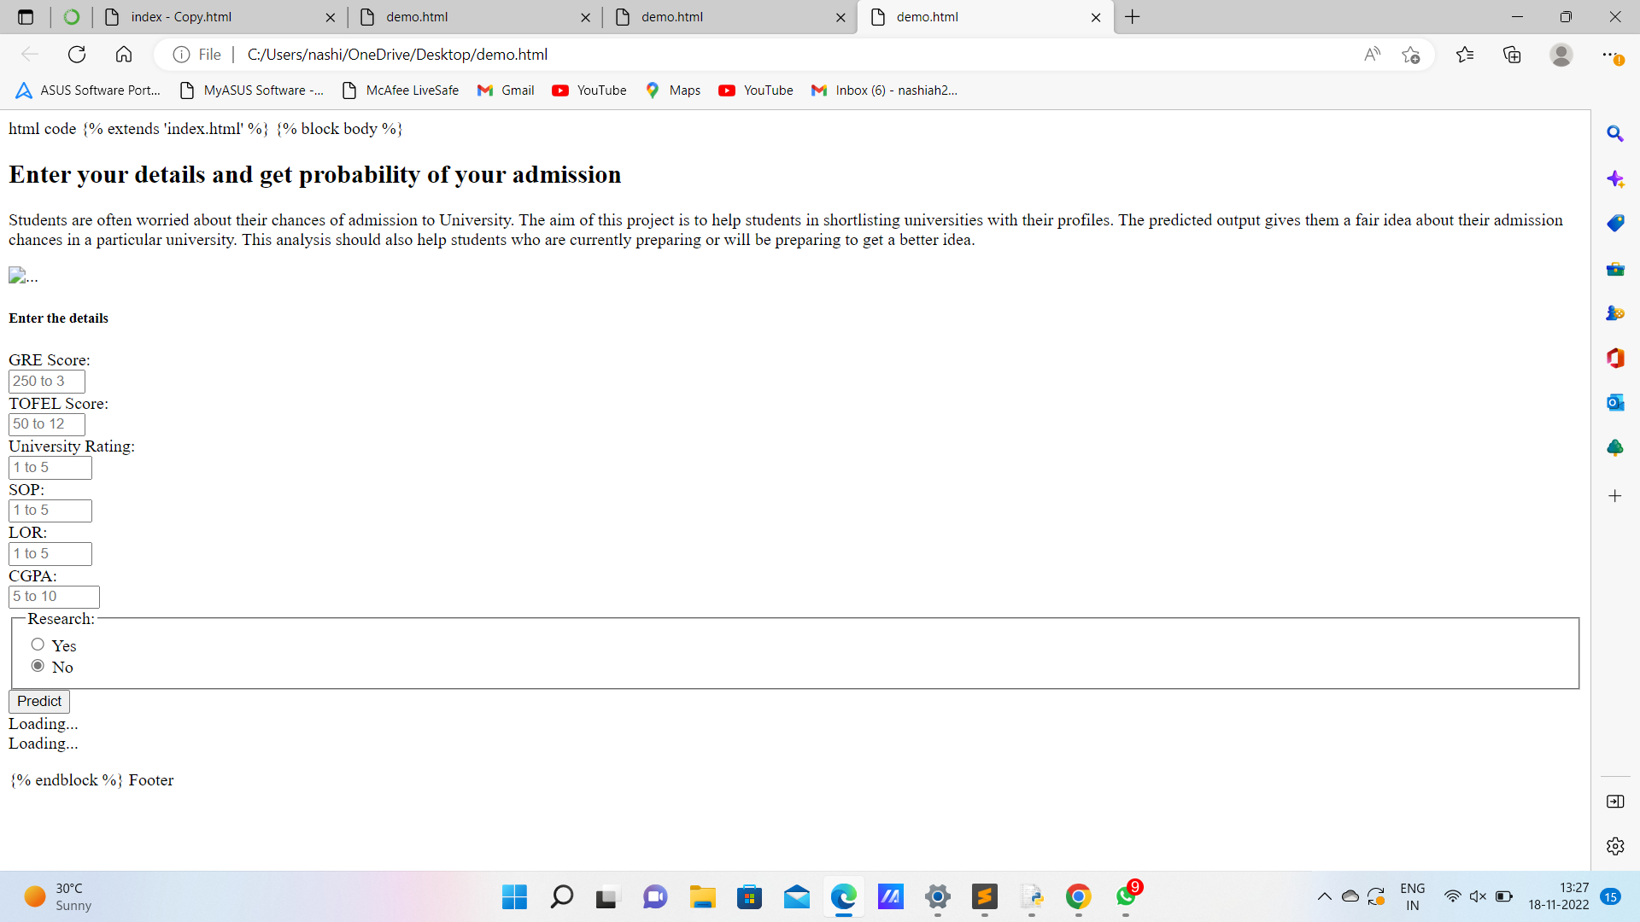

**CHAPTER-9**

**CONCLUSION & FUTURE ENHANCEMENT**

**9.1 Conclusion**

The project uses a Random forest regressor to predict the output and a web application is built to make the UI more accessible and easy using various technologies such as python, HTML5, CSS, Flask, Scikit, Matplot, Numpy, Pandas, Seaborn and other libraries. After the deployment of the web application, it can be accessed from anywhere with internet connection. This project reduces the long hours of analysis to predict the eligibility of the admission to a rated university

**9.2 Future Enhancement**

The future scope of this project is very broad. Few of them are:

* This can be implemented in less time for proper admission process.
* This can be accessed anytime anywhere, since it is a web application provided only an internet connection.
* The user had not need to travel a long distance for the admission and his/her time is also saved as a result of this automated system.